Name Catherine Pollock Date 11/4/14
Laboratory 11: Cover Sheet

Section 1001
Place a check mark in the Assigned column next to the exercises your instructor has assigned to you. Attach this cover sheet to the front of the packet of materials you submit following the laboratory.

Activities | Assigned: Check or list exercise numbers | Completed
Implementation Testing | ✓
Programming Exercise 1 | ✓
Programming Exercise 2
Programming Exercise 3 | ✓
Analysis Exercise 1 | ✓
Analysis Exercise 2 | ✓
 | Total

Name Catherine Pollock Date 11/4/14
Laboratory 11: Analysis Exercise 1

Section 1001

You can use a heap—or a priority queue (Programming Exercise 1)—to implement both a first-in, first-out (FIFO) queue and a stack. The trick is to use the order in which data items arrive as the basis for determining the data items’ priority values.

Part A
How would you assign priority values to data items to produce a FIFO queue?
If using a min heap, where the smallest values are at the top, we would insert new items with larger priority values. That way that would be placed at the bottom rightmost location of the heap. The smallest values, inserted before the larger ones, would dequeue sooner, because they would be trickle up to the root location as more values (smaller than them) were removed.
This would be opposite for a max heap, like we implemented in heap.cpp because you would want to insert smaller priority values as time goes on, so they will go to the bottom of the heap and eventually trickle up as well, once the priority values larger than them are dequeued.

Part B
How would you assign priority values to data items to produce a stack?
For a min heap, where parents are smaller than children, smaller priority values should be inserted each time. This way they are removed before their children are, creating a stack. This would be opposite for max heap though, because the parent would be larger than children, and in return, removed sooner.

Name Catherine Pollock Date 11/4/14
Laboratory 11: Analysis Exercise 2

Section 1001

Part A
Given a heap containing ten data items with distinct priorities, where in the heap can the data item with the next-to-highest priority be located? Give examples to illustrate your answer.

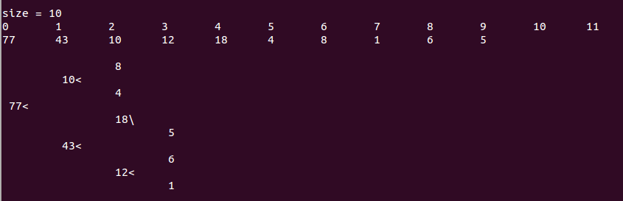
If a heap contained 10 data members, the next-to-highest priority member would be located at index of 1 or index of 2, because the next-to-highest priority member would be one of the root’s children.

Part B
Given the same heap as in Part A, where in the heap can the data item with the lowest priority be located? Give examples to illustrate your answer.
The data item with lowest priority would be located amonst the bottom row of values, such as 5, 6 or 1 in this case, located at indexes 7 8 and 9, respectively. This is because they will be reached last when removed. 8 or 4 could also be low priority if nodes are removed from that side more slowly, but that is not the case in this example.

